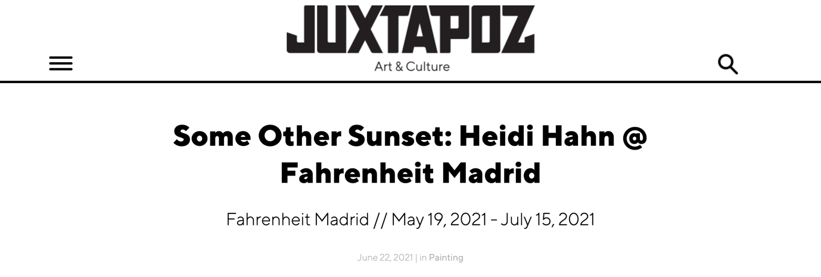

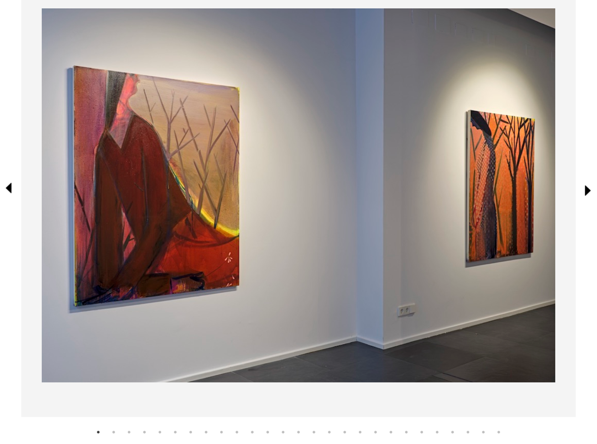

It is so interesting how one can be equally intrigued by the painting in which an illusion of voluminous surface was created through the materiality of paint, as much as the painting in which color choices, their relationships, and the dynamics of the brushwork construct the non-tangible ambiance or emotional state of the work. And the new body of work comprising Some Other Sunset, Heidi Hahn's solo debut which is now on view at Fahrenheit Madrid in Spain, is a great example of the latter.
“In these works, the woman becomes a tool of visual seduction, the formal aspect of the paint delaying ownership over the content. Almost just a residue of its true purpose," Hahn stated in the press release for the show which as a whole serves as a homage to women and their inner lives. Such atmosphere is emphasized through careful color choices, in which subdued, melancholy-imbued, Munch-like hues are contrasted or probed by the bright vibrant tones. With the occasional use of delicate patterns applied over stark gestures, there is a notable balance between the vigor and fragility existing in the images. "The flowers are a way to experiment with color," Brooklyn-based artist told Juxtapoz about the use of these floaty floral embellishments. "It also lends a cohesive structure to the painting, pulling disparate parts together. I also like the vulnerability of decoration as it pertains to the feminine. This is a biased view, how do I manage to talk about something powerful with something seemingly so precious. It's also a seduction method. The flowers seduce in an appealing way, so the viewer becomes implicated in the action of the painting, which deep down is a bit sad."
The sadness of the overall image comes forward with an unusual, skewed composition structure of most of the works, which occasionally diffuses into a clear golden ratio format. Yet, the initially gloomy appearance of such a posture carries a completely different meaning for the artist. "I like the idea of the figure reaching across the surface, of something being stretched over the picture plane," Hahn told us about the compositional aspect of the work which adds to the majestic appearance of her otherwise downcast muses. "These women taking up as much space as they can but also leaning into the corner as if hiding. Wanting to be seen but ultimately not wanting to be known." At the same time, such composition suggests dynamics which is another aspect of the work that goes in hand with the artist's determined yet fluid mark-making. Whether reworking the same image on the smaller works on paper or painting one of the bigger-scale works on canvas, the artist is using the abundance of layering to conceal her muses' physical traits and expressions, while creating a highly suggestive ambiance around them. Such an approach is the result of her respectful and experimental approach to the alchemy of paint and the elusiveness of its materiality. "You can't always control the content you're interested in, but the materiality is always up for grabs," Hahn told us, explaining the importance of the textures and color schemes over the formal aspects of her imagery. The contrast between the suspended ambiance that suggests psychological portraits of femininity, and their monumental, yet skewed appearance, constructs a tension between the traditional and contemporary archetypes of the female form. —Sasha Bogojev

